This template is provided to assist committee chairs to satisfy the reporting requirements found in Faculty Senate Bylaws, Article III, Section 2. Please note the following applicable provisions:

The Chair of each Faculty Senate Committee shall report at least once each semester to the chair of the Executive Committee regarding the business conducted by the Faculty Senate Committee….

It shall be the responsibility of committee chairs to monitor their committee membership’s status and any vacancies (whether occurring by repeated absence, leave of absence, resignation or retirement), and promptly report any occurring vacancies to the Senate leadership.

Email completed reports to facultysenate@unt.edu. Rev. 11-2024
****************************************************************************************
Report to the Faculty Senate Executive Committee Date: 03/11/2025
“x” or circle: Mid-year report X End-of-year report

Committee Name: Faculty Research Committee
Chair or Co-Chairs: Dr. Pam Padilla and Dr. Sundeep Mukherjee
Meetings for the term/year: [insert dates of all meetings to-date, whether electronic or in-person]
In-person Meeting for Fall 2024 on 10/17/2024 and Teams Meeting for Spring 2025 on 03/11/2025
Membership and Attendance (year-to-date attendance record):
These column and row titles may vary based upon the nature of the committee composition. Please highlight names of members missing three or more meetings.

Group Represented, committee office, if applicable | Name | Department or administrative unit affiliation | Term End  (if applicable) | Meetings Attended | Meetings Absent / # Excused
Chair | Sundeep Mukherjee | MTSE | 2025 | 2 | -
Co-chair | Pam Padilla | VPR | NA | 2 | -
Group I | Newly Paul | JOUR | 2027 | 2 | -
Group II | Suliman Hawamdeh | IS | 2025 | 1 | 1
Group III | Maurizio Manzo | ME | 2027 | 2 | -
Group IV | Margie Tieslau | ECON | 2027 | - | 2
Group V | Manjula Salimath | MGMT | 2027 | 1 | 1
Group VI | Karthigeyan Subramaniam | TEA | 2025 | 1 | 1
Group VII | Brian Ayre | BIOL | 2026 | 2 | -
Group VIII | Jamey Kelley | MUED | 2026 | 1 | 1
At-large EC | Priyali Rajagopal | MKTG | 2027 | 1 | 1
At-large EC | Jim Meernik | PSCI | 2027 | 1 | 1
(Add lines as needed)

Do any membership positions need to be replaced at this time due to non-attendance or a leave of members? If so, which positions? (This assumes proper notice was provided per the Procedures Manual; example correspondence and explanation of notice may be found in the Committee Chair Tool Kit.)

No replacements needed at this time.

The Executive Committee establishes charges for each standing committee and may amend them as needed; alternatively, the standing committee may propose amended charges, composition, etc., by making a written proposal and sending to the Faculty Senate office facultysenate@unt.edu.) Do your committee charges remain relevant? If not, what changes to the charges do you propose?

Yes, the charges remain relevant. The committee will assess UNT’s research strategic plans and progress towards meeting TUF benchmarks.

Accomplishments (including items submitted for review or approval to the Executive Committee or Faculty Senate): [bulleted list or narrative]

- The investments from Texas University Fund (TUF) were discussed. Sponsored project data metrics as well as those counting towards TUF benchmarks are accessible through dashboards on the DRI website.
- Recent federal funding guidelines based on executive order were discussed and are updated regularly on DRI website.
- The ongoing research strategic plans for Texas Higher Education Coordinating Board (THECB) were discussed.
- VPRI Padilla pulled data for state universities that are within TX and other states that have similar student demographics as UNT, and the spreadsheet was shared and discussed as shown below. Some of the links shared are below:
https://research.unt.edu/vpri/index.html, https://data.utsystem.edu/data-index/nsf-research-expenditures
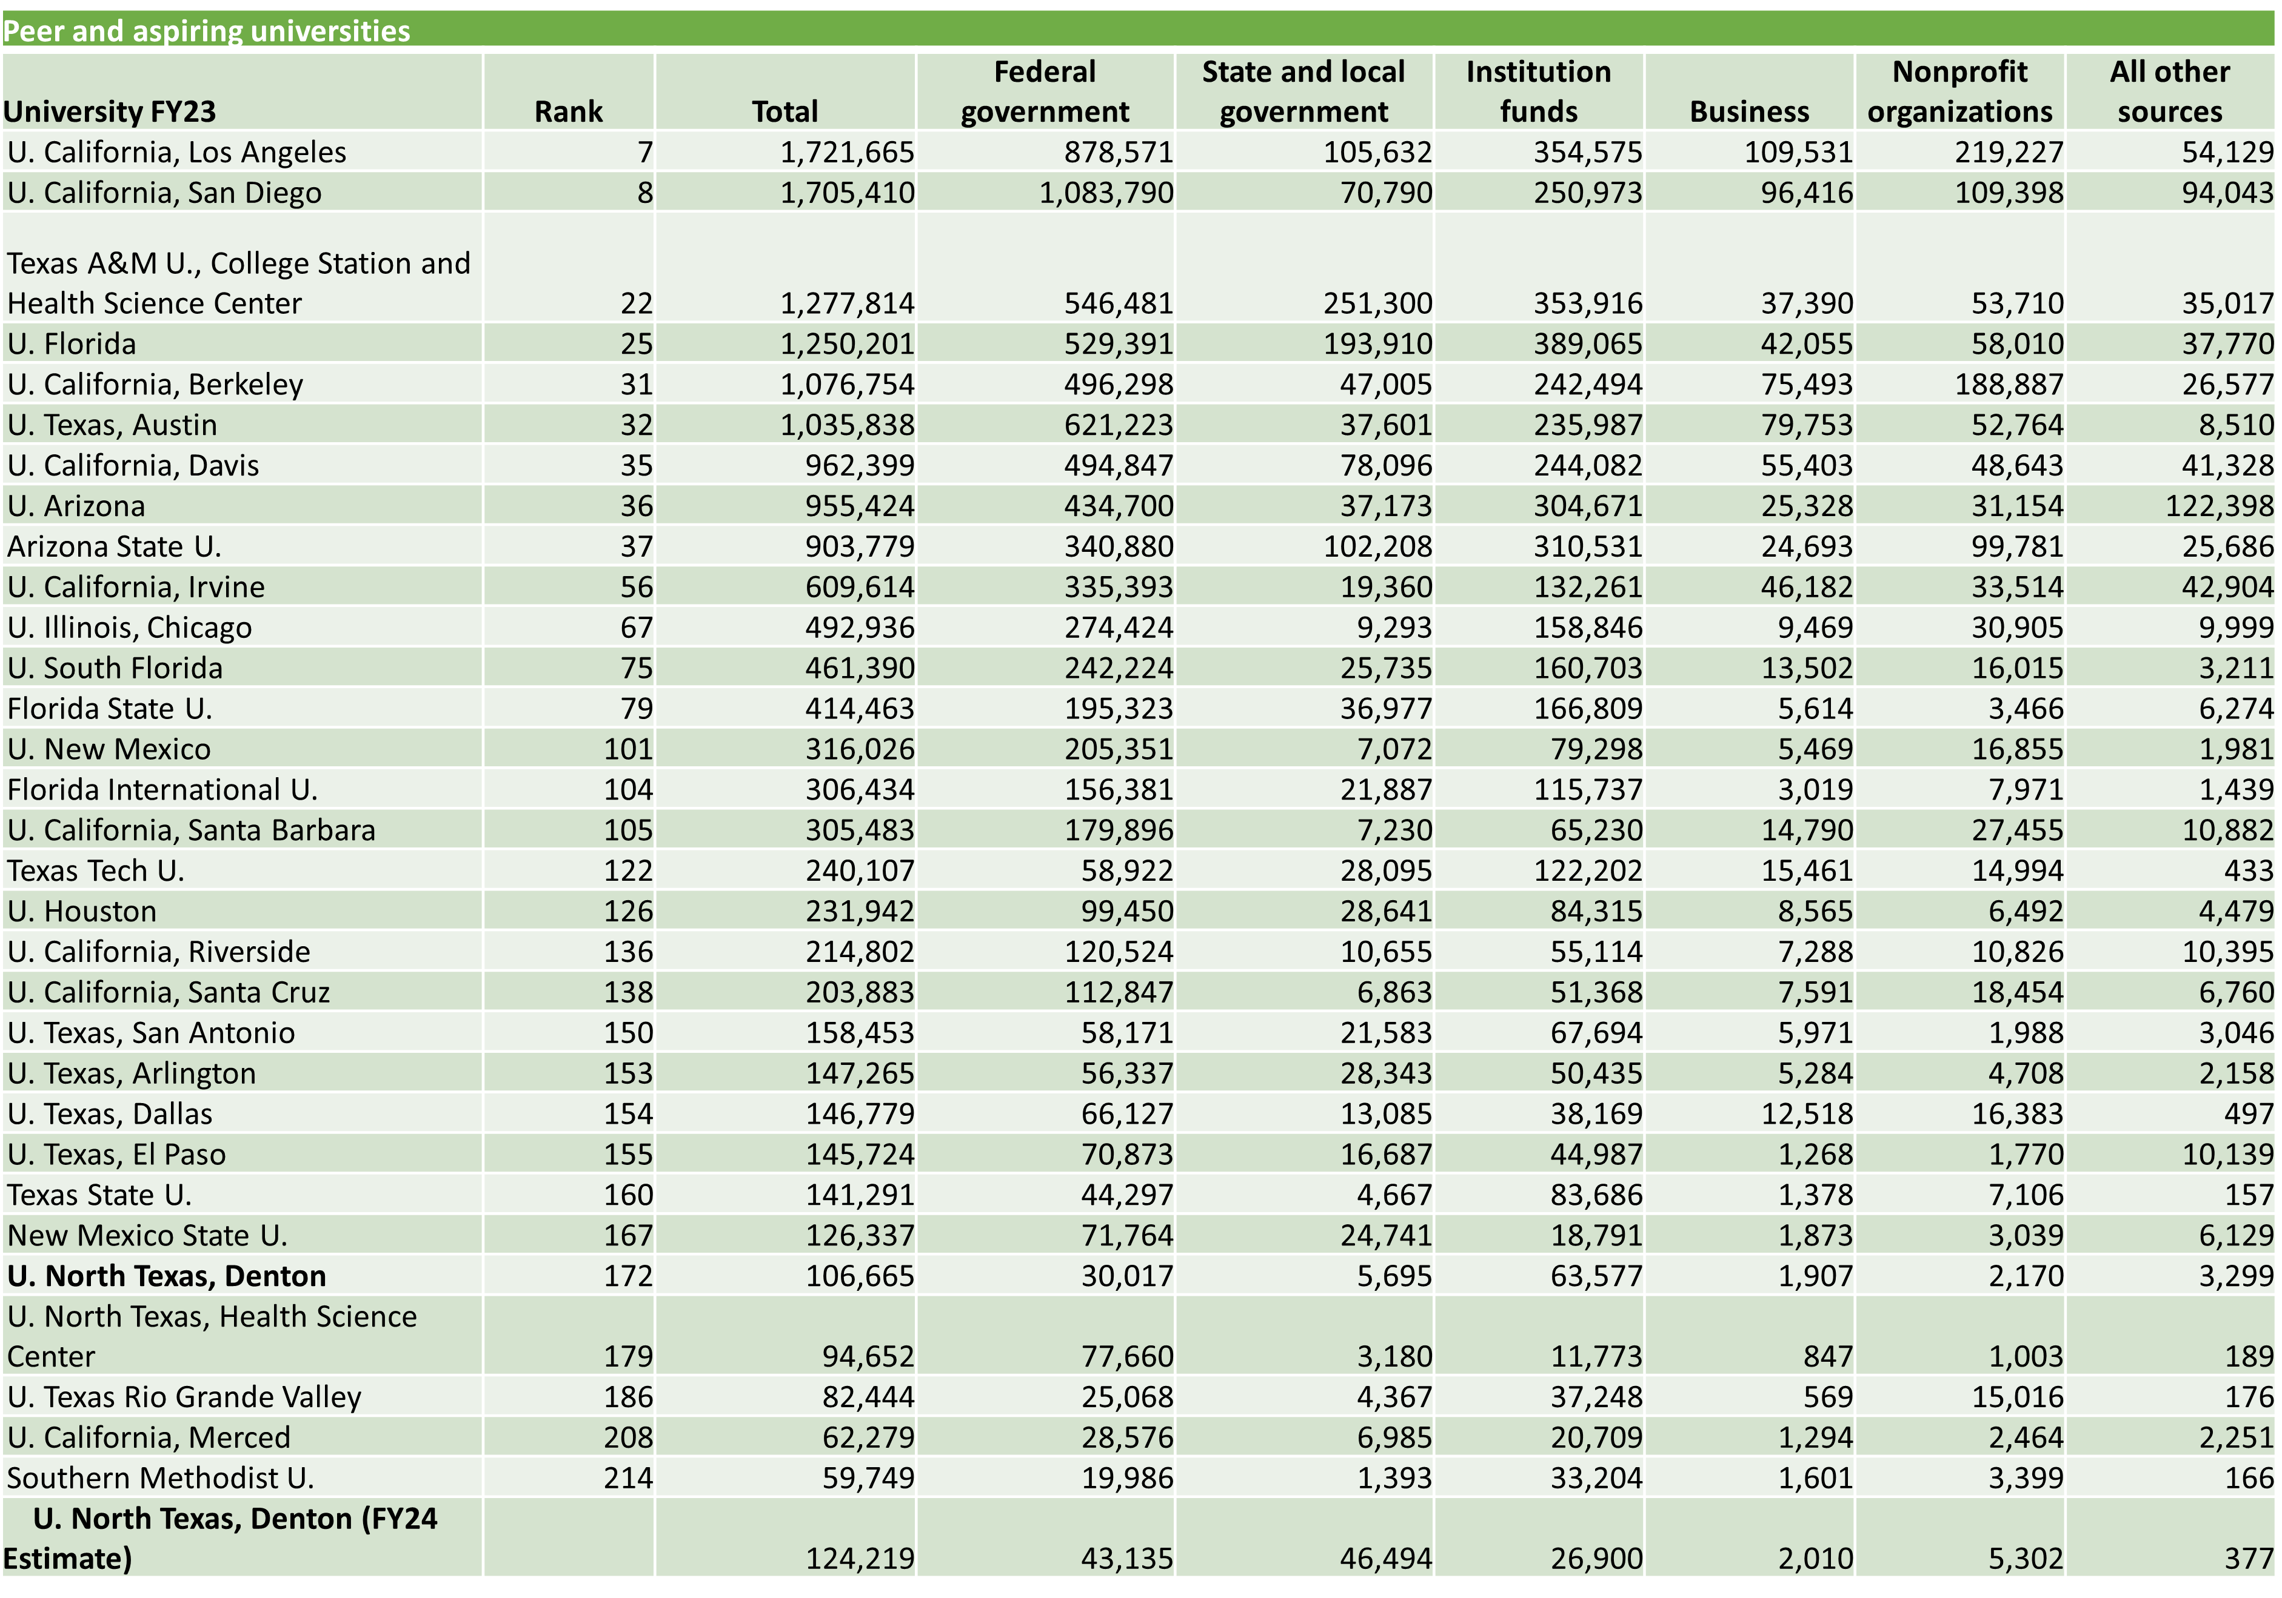

Ongoing/future projects: [bulleted list or narrative]
- Investment and assessment of UNT’s research centers and institutes.

