Response of the Committee on the Status of People of Color to “The University of North Texas: A University of Equitable Opportunities for Faculty?”

A Response by the

Faculty Senate
Committee on the Status of People of Color

Co-Chairs, Roberto Calderon & Jennifer Callahan
Cheylon Brown
Barbara Bush
Spencer Keralis
Daniella Smith
Melody White
Jamaal Young

April, 2014

The UNT Faculty Senate Committee on the Status of People of Color has reviewed the report entitled, “The University of North Texas: A University of Equitable Opportunities for Faculty?” and prepared by the Opportunity Analysis Committee (OAC). The intention of the committee was to examine “current diversity and support of diversity toward the pursuit of UNT’s Four Bold Goals” and prepare a summative report. In reviewing the resultant report, the Committee on the Status of People of Color has prepared this response. We begin by drawing attention to specific positive and negative findings contained within the OAC report that directly impact the focus on our Committee: the Status of People of Color at UNT. We then request amendment to the report in the form of corrections or additions of information. Finally, we request action by UNT administration on three key items.

Positives identified in the report:

- 2006 through 2012 shows a decline in white faculty with a larger decrease at UNT than at institutions reflected in the NCES comparison data. (page 8)

- The percentage of black and Hispanic Education faculty is higher at UNT (than found in other institutions reflected in the NCES comparison data). (page 14)

- UNT has a higher percentage of black faculty in Information than found in other institutions reflected in the NCES comparison data). (page 16)

- There was a higher percentage of Hispanic faculty hired in comparison to the percentage of Hispanic graduate students earning degrees. (page 29)

- Average time in rank suggests that ethnically/racially diverse faculty are performing as well as, or better than, other faculty. (page 54)

Negatives identified in the report:

- There is conflation of ethnicity and race constructs throughout the report, which obscures optimal parsing of data and comparisons to other data sources.

- There is a lower percentage of UNT black faculty (4% in 2012) in comparison to the percentage of black undergraduate students (13% in 2012). (page 6)

- There is a lower percentage of UNT Hispanic faculty (5% in 2012) in comparison to the percentage of Hispanic undergraduate students (18.7% in 2012). (page 6)

- "The percentage of Hispanic faculty seems disproportionate in regard to meeting the needs of this growing population on campus-in regard to serving as advisers, mentors, and role models for the growing group of Hispanic students." (page 9)

- The College of Business has a higher percentage of white faculty than other institutions reflected in the NCES comparison data. (page 11)

- UNT Engineering faculty is represented by a lower percentage of black faculty than found in other institutions reflected in the NCES comparison data. (page 15)

- There is a higher percentage of white faculty in Music than found in other institutions reflected in the NCES comparison data. (page 18)

- The UNT Visual Arts and Design faculty are comprised of a lower percentage of Hispanic faculty than found in other institutions reflected in the NCES comparison data. (page 21)

- UNT Journalism is significantly less diverse than found in other institutions reflected in the NCES comparison data. (page 22)

- The number of white faculty hired at UNT shows an increasing trend. (page 24)

- Neither African-American nor Hispanic faculty hired in 2006 were present at UNT in 2012. (page 37)

- The “key points” listed in section 3.2 note that the overall faculty attrition rate at UNT was 22.82% from 2000 to 2012. (Page 39) However, this analysis obscures meaningful differences in attrition rates according to race/ethnicity. In response to this Committee’s request for additional data we were able to compute new attrition rates: American Indian: 40% attrition; Black: 51% attrition; Caucasian: 32% attrition; Hispanic: 37% attrition (see page 5 of this response for details and illustration).

- The growth in salary from 2006 to 2012 was significantly higher among white male faculty and outpaced all other races and ethnicities (of note, there appears to be an interaction of gender x ethnicity here). (page 22)

Needs for amendment of report:

- The summative note on the bottom of page 17 is incorrect and should be amended to reflect that UNT has a higher percentage of Asian (not Black, as indicated) faculty in MHT.

- Page 23's key points omits several of the findings highlighted herein and should be amended to be fully inclusive of the ethnicity findings.

- Pages 44 through 48 report the average salaries for faculty by college and gender in academic years 2006 and 2012. Section 4.3 (p. 49-50) then presents calculations of the “male advantage” in salary. Parsing of data as it pertains to race/ethnicity, including consideration of differential race/ethnicity advantages, is not included in the report.

- Time in rank from associate to promotion to full professor is not provided by race/ethnicity (although it is reported for gender on page 55, table 17) and should be included. If the sample size is insufficient for report, then this problem should be overtly noted as a limitation to the report and specifically noted as a salient indicator of insufficient faculty race/ethnicity diversity.

- Analyses of administrative positions completely omit consideration of race/ethnicity. Table 19 on page 57 should be amended to include the fall 2012 frequency data. The following data was provided by the Opportunity Analysis Committee upon request for additional information by the Faculty Senate Committee on the Status of People of Color:

“Based a counting of Administrators as of fall, 2012, the following ethnicities were represented:
Academic Dean Level: Asian = 2; Caucasian = 13
Dean Level: Black = 1; Caucasian = 11; International = 1
Chair: American Indian = 1, Asian = 4; Black = 2; Caucasian = 42; Hispanic = 3; International = 2
Sr. Assoc. Dean, Provost, VP Level: Caucasian = 7; Hispanic = 1
Other Administrative Roles: Caucasian = 5.”

- Page 58 provides “key points and findings” but completely omits consideration of race/ethnicity. Page 58 should be amended to include points 3 thru 5 above. The following figures and summations should be inserted into the report:

Race/ethnicity salary differences occur at the time of hire and yield progressively compounding disparities in salary.
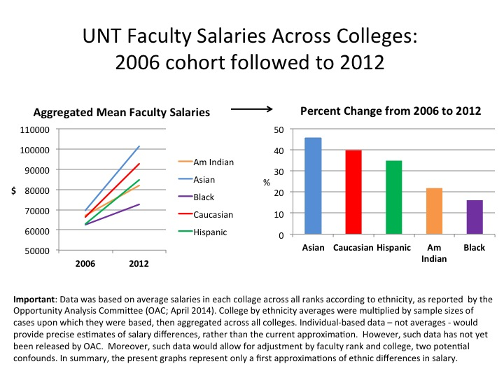

Salary disparities are inversely associated with faculty attrition. Stated another way, the greater the salary disparity the more likely a faculty member will leave UNT. Faculty attrition directly conflicts with the goal of attaining a faculty that is representative of our State’s demographics.
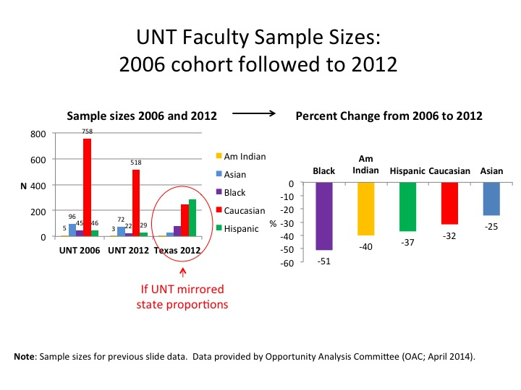
Progressively compounding salary disparities do not appear to be explained by quality of work. Ethnically/racially diverse faculty spend less time in rank at the assistant professor level and attain tenure more quickly than Caucasian faculty.

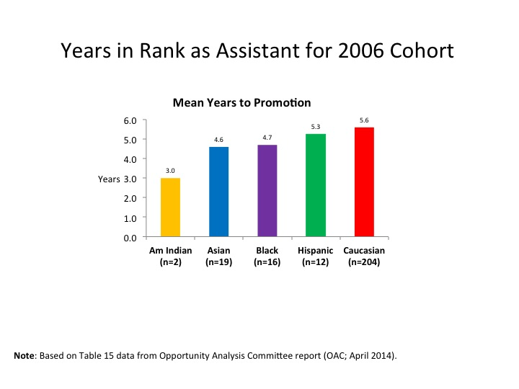
Summary and Requests for Action:

The Committee on the Status of People of Color has significant concerns regarding the experiences of ethnically/racially diverse faculty at UNT. We appreciate the work of the Opportunity Analysis Committee (OAC) in assembling the available data and their responsiveness to our requests for more information. In addition to requests above for amendment to the OAC Report, we propose the following action items:

- Request: Realignment to substantially increase racial/ethnic diversity in administrative appointments.

Rationale: In response to our request for more information, it has become clear that the percentage of racially/ethnically diverse administrators is disproportionate in regard to meeting the needs of the increasingly diverse campus population. As shown below, the current and future needs of UNT students necessitate improvement in this regard. More specific to faculty, we note that the current faulty contains three times greater racial/ethnicity diversity than is observed in upper administration.

In light of the salary disparities and increased attrition among racially/ethnically diverse faculty it appears that upper administration has insufficient representation of racially/ethnically diverse administrators to serve as advisers, mentors, and role models for the growing group of racially/ethnically diverse faculty.
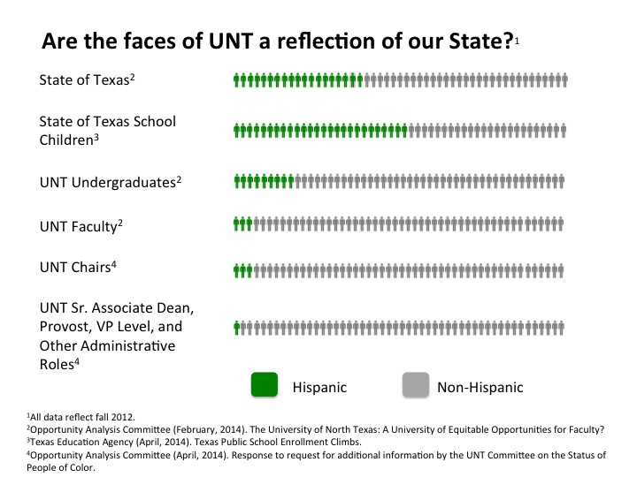

- Creation of a fund for corrective salary adjustments to racially/ethnically diverse faculty members.

Rationale: Race/ethnicity salary differences occur at the time of hire and yield progressively compounding disparities in salary over time. There appears to be a salary bias at the time of hire and in subsequent salary increases that places Hispanic, Black, and American Indian faculty at a financial disadvantage despite data on time in rank indicating that these faculty members are performing as well as, or better than, the dominant (Caucasian) faculty group. The data further suggests that salary inequities may be associated with faculty attrition.

Further, it is important to couple the data from the OAC report with the previously released findings from the UNT Climate Survey, which also captured data from the fall 2012 faculty cohort.

Hiring includes a conscious effort to generate a diverse pool of applicants
Hiring is consistent for all applicants
I sometimes collaborated with members of my department
The tenure and promotion process is fair and consistent
Faculty from underrepresented groups are treated fairly at UNT
How comfortable would a new faculty member from your race/ethnicity be in your department?
How likely would you be to work at UNT, knowing what you know now?
How likely would you be to leave UNT if not for family?
How much stress do you feel about subtle discrimination?
UNT should hire more faculty from underrepresented groups
Black
Hispanic
Caucasian
Asian

As shown by the above sparkline summary (red line indicates the lowest value), Black and Hispanic faculty consistently reported negative subjective appraisals of the UNT climate on key variables salient to hiring, retention, promotion, and tenure. When the Climate report and the Opportunity Analysis Committee report are considered in concert, a clear and concerning pattern emerges that necessitates action. Salary adjustments are an important action step to resolving objective inequalities and acknowledging the range of adverse experiences of impacted faculty.

- Routine data capture going forward to monitor the impact of the above action items. Such data collection should be careful to document race and ethnicity as separate constructs. Utilization of census categories is recommended to facilitate comparisons with other data sources in the future.

Rationale: The report provides evidence of long-standing and pervasive inequity in the status of faculty of color at UNT that merits careful tracking over time.

